View & Do

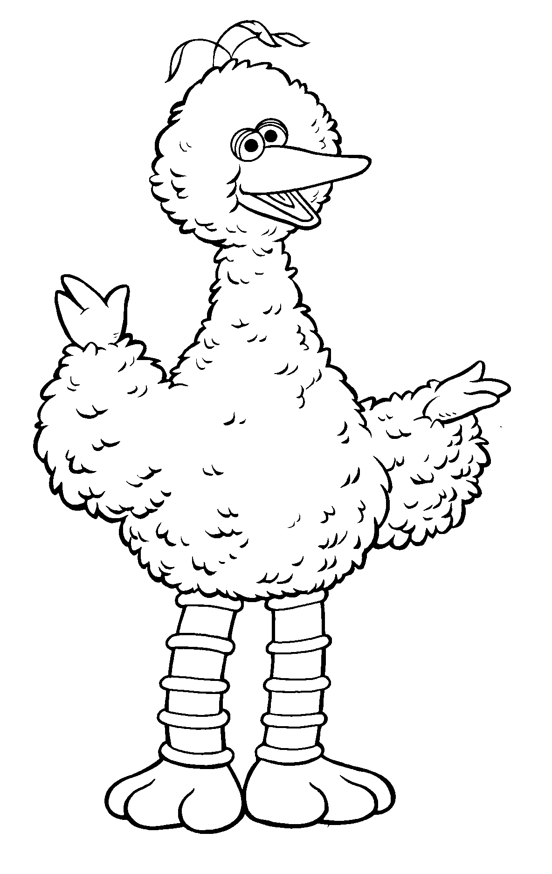 | 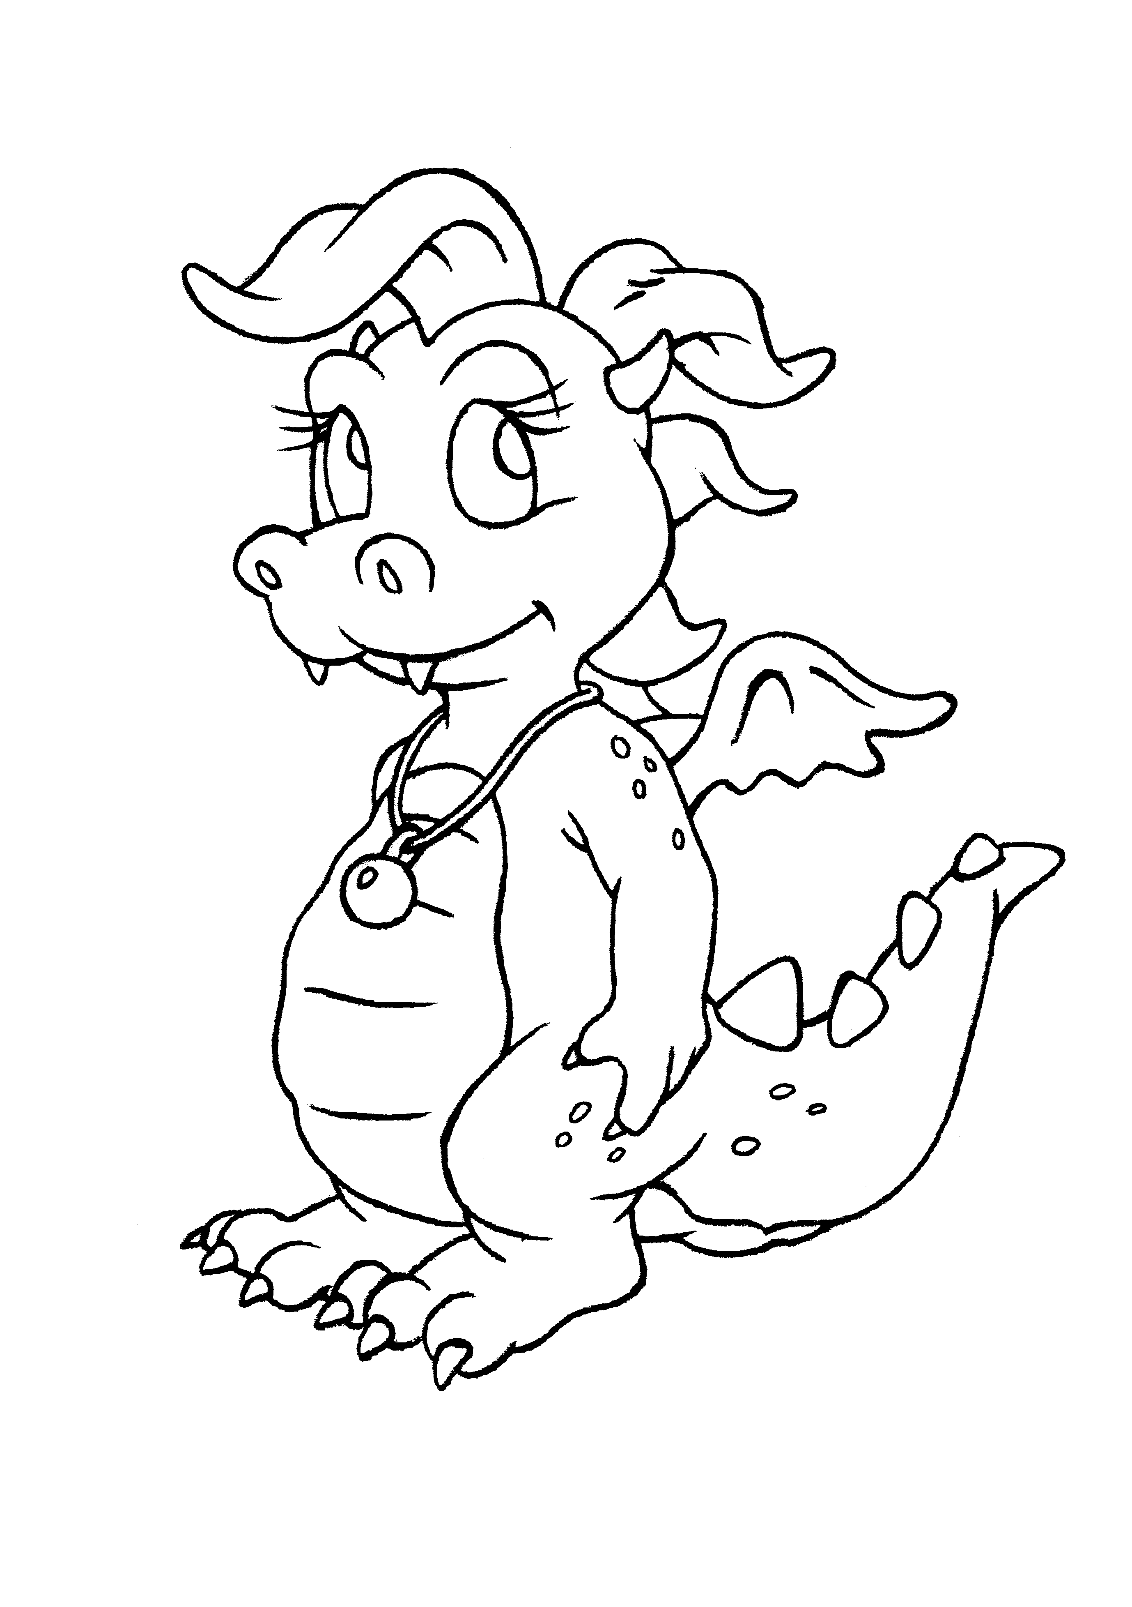 | 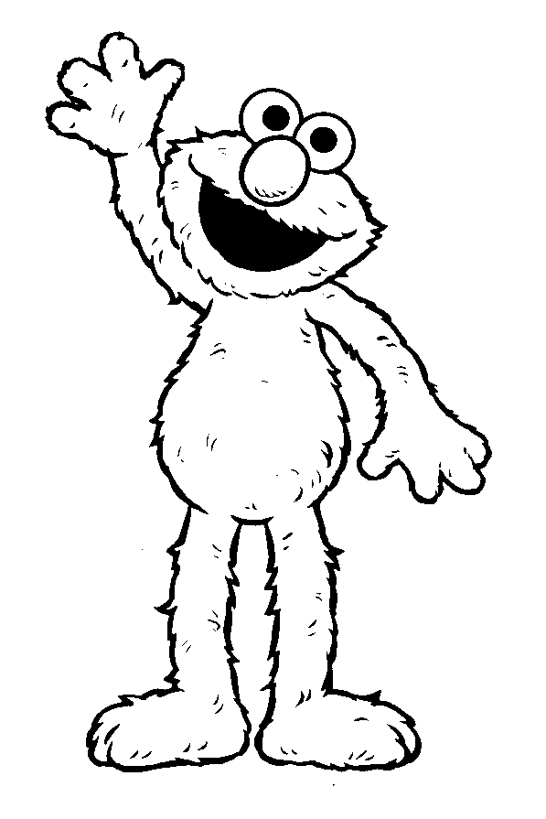 | 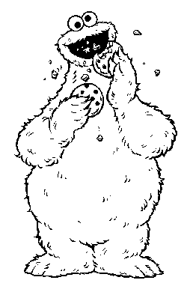 | 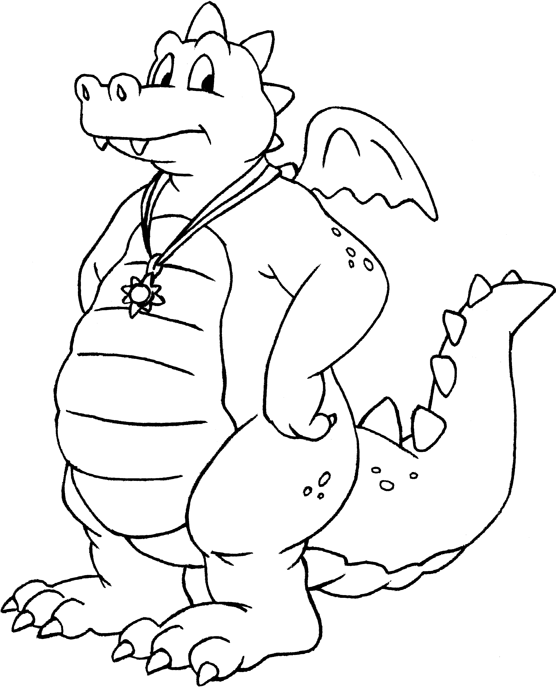

Issue 5 | Your Monthly Viewing Guide | May 2001

It is Sing-A-Long Day on Sesame Street!
The whole gang is going to sing songs and you are invited to sing along.

Elmo, Maria, Gabi, Big Bird, Telly and Lulu invite you to join them as they sing their favorite songs. Enjoy learning new songs and practicing some songs that you might already know.
Singing is fun and something that everyone can enjoy. Singing is a great way for children to express themselves and learn new words. You can sing anytime and it always brings a smile to your face.
So just remember to
Sing, sing a song!
Sing out loud, sing out strong.
Don’t worry that it’s not good enough for anyone else to hear.

Just sing,

Sing a song!
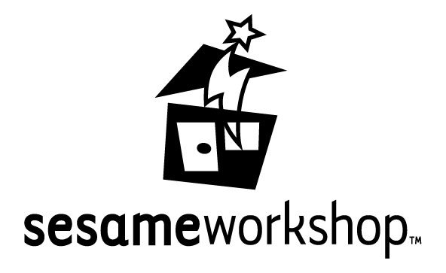

© 2001 Sesame Workshop. Sesame Street Muppets © 2001 Sesame Workshop. “Sesame Street,” “Sesame Workshop” and their logos are trademarks of Sesame Workshop. All rights reserved.
Dragon Tales is funded in part by a grant from the Corporation for Public Broadcasting through funds from the U.S. Department of Education. Dragon Tales is underwritten in part by Kellogg’s Rice Krispies® and Frosted Flakes® cereals.

© 2001 Sesame Workshop/Columbia Tristar Television Distribution. Dragon Tales and its logo are trademarks of Sesame Workshop and Columbia Tristar Television Distribution. Sesame Workshop and its logo are trademarks of Sesame Workshop. All rights reserved.

See it on PBS KIDS logo TM & © PBS. All rights reserved. Used with permission. Funded in part by a Ready To Learn grant from the U.S. Department of Education through the Corporation for Public Broadcasting.

Your Turn
Join in the fun with these helpful hints and activity ideas!
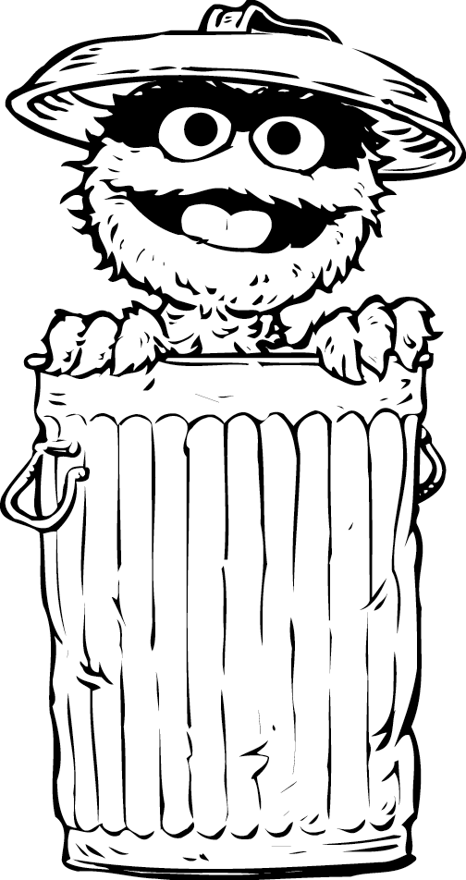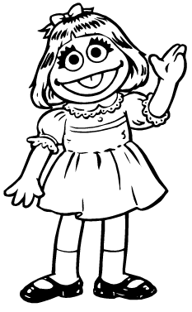

Theme: Singing and Making Music

Sing a Song!
Take turns singing songs that you already know. First sing them together, and then encourage your child to sing some of it by herself. The song “Where is Thumbkin?” is a great song to sing together because you can do hand movements along with the words and since the song is so repetitious it is easier for children to learn. Another activity you can do is encourage your child to sing some of the words alone. Like you sing “Twinkle, Twinkle Little ______”, and have her fill in the words. Then go from there!

Listen to the Music Play
Turn on the radio or play different tapes or CDs and listen to different types of music together. Have fun moving to the music. And try to sing along with some of the music that you hear and if you don’t know the words hum along or sing lalala along with the tune.

Have a Singing Day
Instead of saying, “What would you like for lunch?” sing it! Have fun singing things that you say to each other. Play a game where you sing a word in a certain tune and have your child sing it back to you. Then let them have a turn and you repeat. For extra fun make a drum or use something around the house to use like a drum and tap along as you sing.

READ
Chicka Chicka Boom Boom by Bill Martin

Wheels on the Bus by Raffi

To see more about singing and making music watch:
Sesame Street shows # 3946, 3949

Dragon Tales shows # 105,135

Don’t forget to check us out online
Go to: www.sesamestreet.com
www.pbskids.org/dragontales
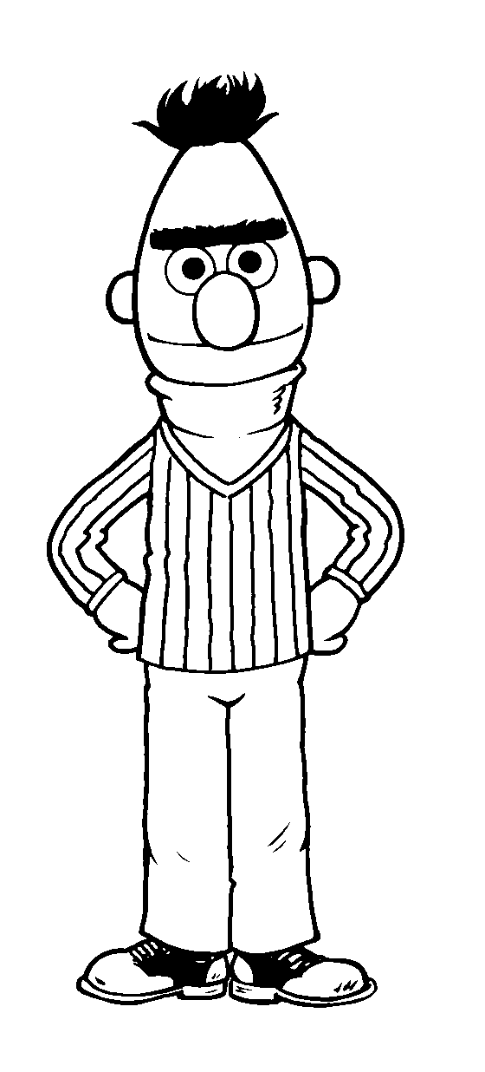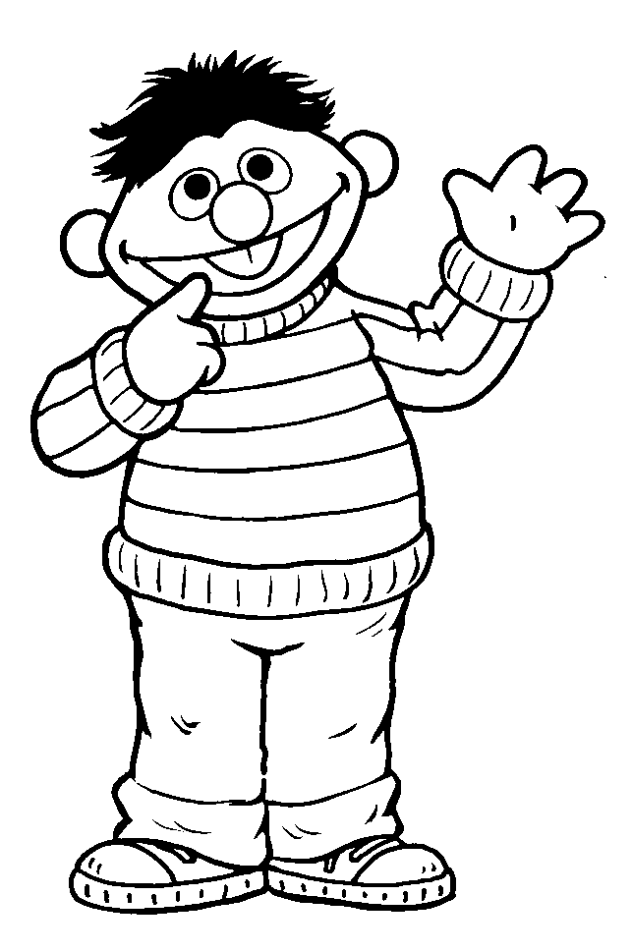

SESAME STREET FAMILY TIPS

May 2001
3937  Elmo, Zoe and Big Bird want to play together but they all want to do different things, so they compromise and find a way to do all three activities. Tip: Ask your child what they would have done in this situation. Letter and Number: N, 3. |  | 3949  Telly’s tuba is broken and so he finds other ways to make music. He soon discovers that music is all around him. Tip: Find different ways to make music. Letter and Number: M, 7.
3938  Maria is supposed to be working but she ends up taking care of a few of her friend’s pets. Tip: Talk about the different things that you have to do to care for a pet. Letter and Number: M, 12. |  | 3950  Elmo joins Oscar’s All Grouch Band after spending some time practicing being a grouch. Tip: What are some ways Elmo acts like a grouch? Letter and Number: J, 0.
3939  Elmo is watching Miles play basketball with the older kids and he feels sad because he wants to be involved. Eventually Miles and Elmo play together and this makes Elmo feel better. Tip: Read Jamaica Tag-Along by Juanita Havil. Letter and Number: O, 10. |  | 3951  There is an alphabet explorer on Sesame Street and Telly, Elmo and Baby Bear decide to help him on his quest to find the wild, exotic, dotted, dinging letter “D.” Tip: Use the first letter of your name and go on a hunt to find other things that begin with that letter. Letter and Number: D, 1.
3940  Alan puts up a sign in Hooper’s store that causes Telly to have some confusion. It reads, ″Hooper’s Store: where you can have what you want, just the way you want it.” Tip: Walk around your neighborhood and look for signs in stores and restaurants and read them together. Letter and Number: C, 15. |  | 3952  It’s sing along day on Sesame Street and everyone shares his or her favorite songs, including a Spanish counting song from Maria. Tip: Sing along with your Sesame Street friends and then sing some other songs you know.  Letter and Number: Z, 16.
3941  Zoe pretends to be Suzie Kabloozie and is frustrated because Big Bird and Telly will not play with her. Zoe realizes that Big Bird and Telly want to finish playing their games first, she apologizes, and they all play Susie Kabloozie. Tip: Pretend to be one of your favorite characters from a book that you like.  Letter and Number: F, 13. |  | 3953  Baby Bear practices counting with the Count. Tip: Practice counting to ten using your fingers to help you. Then find other objects to count. Letter and Number: Y, 3.
3942  Big Bird and Snuffy are host of the letter “B” show, and they present words that begin with “B”. Tip: Practice saying the “B” sound and think up other words that start with the letter “B.” Letter and Number: B, 3. |  | 3954  Ernie starts an “instant poetry service” by creating rhymes about what his friends on Sesame Street are doing. Tip: Think of some words that rhyme. Start by saying the words in the poem Jack and Jill and talk about how the words rhyme.  Letter and Number: A, 2.
3943  It’s a Cooking Day on Sesame Street and everyone cooperates to make snacks. Tip: Make your favorite snack and share it. Letter and Number: P, 20. |  | 3955  Baby Natasha’s mom and dad get very excited by Baby Natasha’s scribbles. Tip: Everyone is an artist, including you, so get some crayons and draw away! Letter and Number: G, 7.
3944  Telly and some other Sesame Street friends try to help Baby Bear get rid of his hiccups. Tip: What do you do when you get the hiccups? Letter and Number: H, 15. |  | 3956  Big Bird and Baby Bear have a play date together and even though they are different they discover the many things that they both like to do. Tip: Read Margaret/ Margarita by Lynn Reiser. Letter and Number: B, 3.
3945  Elmo, Baby Bear, and Telly create bongo drums out of oatmeal containers and become the fabulous hit band the ‘Bongo Boys.” Tip: Listen to different kinds of music together and see if you can hear the sound of the drums! As you listen for the drums in different music use something around the house as a drum and play along. Letter and Number: V, 4. |  | 3957  Zoe uses her Zoemobile to make deliveries all over Sesame Street. Tip: Talk about what a mailman or a mailwoman does and practice mailing a letter. Letter and Number: Z, 20.
3946  Join Ernie for a play date with Rubber Duckie where Ernie invites you to sing and clap along with him and the Birdketeers.  Tip: Talk about a favorite stuffed animal or doll and what you like to do with it. Letter and Number: X, 11. |  | 3958  Miles makes a home video for a school project. Tip: If you were going to make a movie or a home video about something what would it be? Letter and Number: F, 5.
3947  Snuffy and Big Bird are hosting the Alphabet Show and when they ask Zoe to join she would rather count so they host the Counting Show. Tip: Pretend to host your own show.  Letter and Number: L, 8. |  | 3959  Oscar has a trash sale to make more room in his trashcan so that Fluffy can dance. He realizes that it is too hard to part with his trash, so he decides to keep his trash and move it whenever Fluffy dances. Tip: Have you ever felt how Oscar is feeling? Letter and Number: T, 9.
3948
Elmo pretends to be a cat and plays a lot of cat games. Tip: Pretend to be your favorite animal and imitate how it moves and makes sounds. Letter and Number: C, 18.

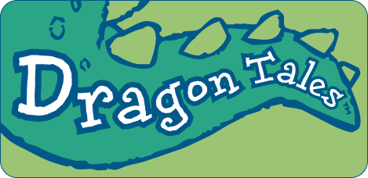 | dragon tales family Tips  May 2001
128 Sand Castle Hassle  The kids and dragons work hard building sand castles for the Turtle Dragons, but when they build them too close to the water they get washed away so they rebuild them on higher sand.  Tip: Discuss something that you had to try a few times until it worked out. |  | 140 Don’t Bug Me  The gang sets out to find a beautiful Flutterby for Quetzal but Ord is scared of bugs. Max has a hard time understanding Ord’s fear. Tip: Read The Kissing Hand by Audrey Penn.
129 Zak Takes a Dive  Zak is afraid to learn how to swim and Wheezie reminds him that there are many things that he did not want to do at first but liked after he tried them. Tip: Discuss something you tried and how you felt doing it. |  | 103 Ord’s Unhappy Birthday  Max and Emmy are planning a surprise party for Ord’s birthday and nobody has time to play with him. Tip: Discuss Ord’s feelings.
130 My Emmy or Bust  Max goes to Dragon Land without Emmy to help the gang to find a missing Sea Dragon but he misses his sister. Tip: Write a letter or draw a picture for someone that you miss. |  | 104 Calling Dr. Zak  When Zak steps on a Spineypine and gets a splinter in his foot he needs to see Dr. Booboogone, but he is afraid of going to the doctor. Tip: Take turns pretending to be a doctor.
131 Follow the Leader  Emmy leads an especially hard game of “Follow the Leader” and Max is having trouble keeping up. Emmy realizes how Max felt when Pooky, the troll, plays his version of “Follow the Leader” with Emmy. Tip: Discuss how Max and Emmy felt. |  | 105 Zak’s Song  The children and the dragons want to join the Do-Re-Mi birds in their beautiful singing but their loud attempts only frighten the birds. Zak has a quieter solution if only they would listen.  Tip: Think of ways that Zak could have made his friends follow his suggestions.
132 Rope Trick  When a bottle of Quetzal’s special potion spills on Zak and Wheezie’s jump rope, it magically comes to life. The only way to return it to normal is to catch it and jump over the rope three times. Tip: Pretend you are Zak and Wheezie and practice jumping rope. |  | 106 The Fury is Out On This One  Max feels frustrated so he throws a seed pod at a tree and out pops a Fury! The angrier Max gets the bigger the Fury grows. Tip: Read Alexander and the Terrible, Horrible, No Good, Very Bad Day by Judith Viorst.
133 Roller Coaster Dragon  The kids and dragons get a lesson in being patient when they have to wait in line to ride the roller coaster. Tip: Discuss two things you could do while waiting and practice them. |  | 107 The Big Sleepover  Cassie is nervous about her first sleepover party. She ends up going to the sleepover for as long as she feels comfortable. A wonderful partial success! Tip: Talk about some of the goals that you are working towards.
134 Wild Time  The dragons are finishing their projects for the Dragon Scale Festival, but Max has a case of the sillies. Tip: Discuss how Max was making Emmy and the dragons feel. |  | 108 Talent Pool  Cassie can’t think of a talent for the school show so she asks the Talent Pool. The Talent Pool is upset and Cassie cheers her up and realizes that her talent is helping people. Tip: What would you do if you were in a talent show?
135 Whole Lotta Maracas Goin’ On  Quetzal’s maracas are broken so the gang works together to make him a new pair for Teacher’s Day. Tip: Read Clever Sticks by Bernard Ashley. |  | 109 Dragon Sails  Ord is making a sailboat for a Rainbow Crystal expedition but he is too big for his own boat! Tip: Read Bein’ With You This Way by W. Nikola Lisa.
136 Ord Sees the Light  Max’s frog friend Hoppy goes into a cave. Ord works to overcome his fear of the dark because he know how excited Max is to play with Hoppy. Tip: Read Where the Wild Things Are by Maurice Sendak. |  | 110 A Liking to Biking  Emmy and Max bring their bikes to Dragon Land and try to teach the dragons how to ride. Tip: Describe how you learned to ride a bike.
137 Out with the Garbage  Wheezie is upset because Zak cleaned up her side of the room. He threw out her “junk” which to her were her “treasures.”  Tip: Read Hattie and the Fox by Mem Fox. |  | 111 Four Little Pigs  Zak and Wheezie are upset because they can’t be the characters they wanted to be in the puppet show, so to solve the problem they change the story to become the Four Little Pigs.  Tip: Discuss why Zak and Wheezie needed to change the story.
138 Bully for You  Cassie meets Spike, the new dragon in school, but he is acting like a bully. Cassie realizes that he is behaving this way because he is lonely. Tip: Talk about what you would say to someone like Spike and act is out. |  | 112 A Feat On Her Feet  Everyone helps Cassie learn to skate so they can get the Jingle Flowers to the Singing Springs for some of the fountain’s musical water. Tip: Pretend you are skating and talk about the safety equipment you will wear.
139 Much Ado About Nodlings
Max accidentally drives his toy bulldozer into a wagon that the tiny gnomes are using to gather mushtrees. The Giant of Nod wants Max to fix what he has done. Tip: What are some ways that Max could fix the situation?

